|  |  |  |
| --- | --- | --- |
| **LAB 321 Assignment** | **Type:** | **Long Assignment** |
| **Code:** | **J3.L.P0013** |
| **LOC:** | **500** |
| **Slot(s):** | **15** |

**Title:** The Sushi restaurant

**Background**

### Sushi is a food preparation [originating in Japan](https://en.wikipedia.org/wiki/Japanese_cuisine), consisting of cooked vinegared rice combined with other ingredients (such as raw seafood, vegetables and sometimes tropical fruits. Ingredients and forms of sushi presentation vary widely, but the ingredient which all sushi have in common is rice (also referred to as shari (しゃり[?](https://en.wikipedia.org/wiki/Help:Installing_Japanese_character_sets" \o "Help:Installing Japanese character sets)) or sumeshi (酢飯[?](https://en.wikipedia.org/wiki/Help:Installing_Japanese_character_sets))).

If you want to startup with your The Sushi restaurant, try this assignment ☺

Reference site: <http://us-123sushi.simplesite.com/>

**Program Specifications**

Program a web site to introduce your sushi restaurant to your customer, detail functions of this website is described below

**Features:**

This website contains 4 main functions

* Function 1 : Home page : ( see PIC 01)
  + Display introduction entry and all menu
  + Each product contains
    - Entry name
    - Description picture
    - Entry content
* Function 2 : Price list ( PIC 02)
  + Print out detail price of each menu
* Function 3 : Contact us ( PIC 03)
  + Allow user contact via contact form .

You do not need to write interface for admin control panel, you can add data manually (use SQL SERVER Management studio).

Note: All data must be load from database, not hard code in page.

***Expectation of User interface:***

Pic 01 : Home Page

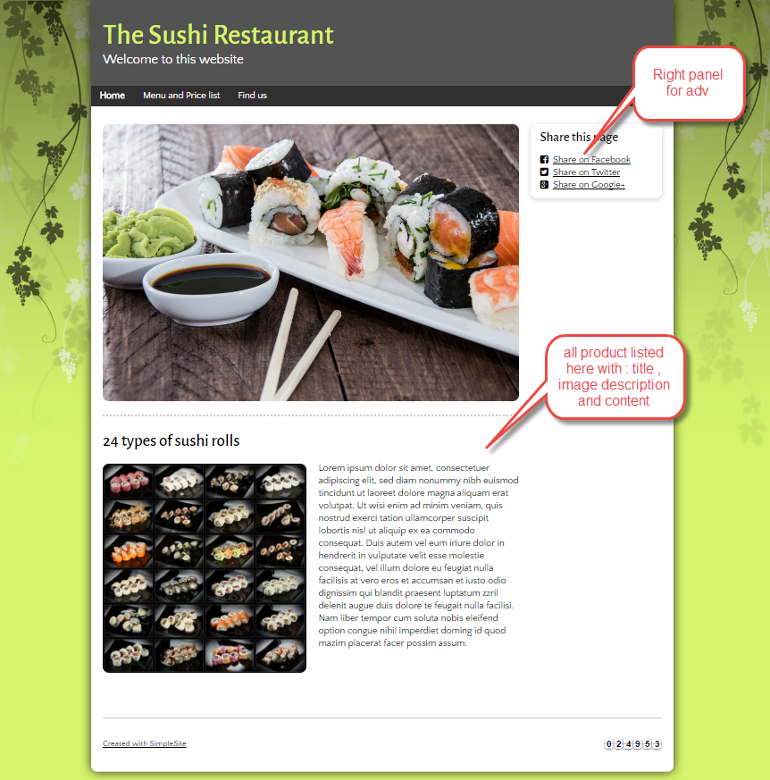

PIC 2 : Menu and price

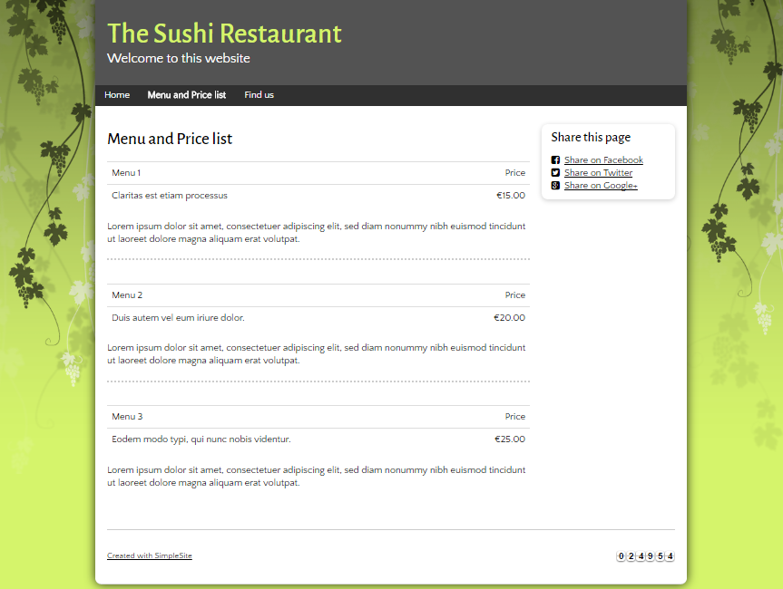

Pic 03 : Contact us page

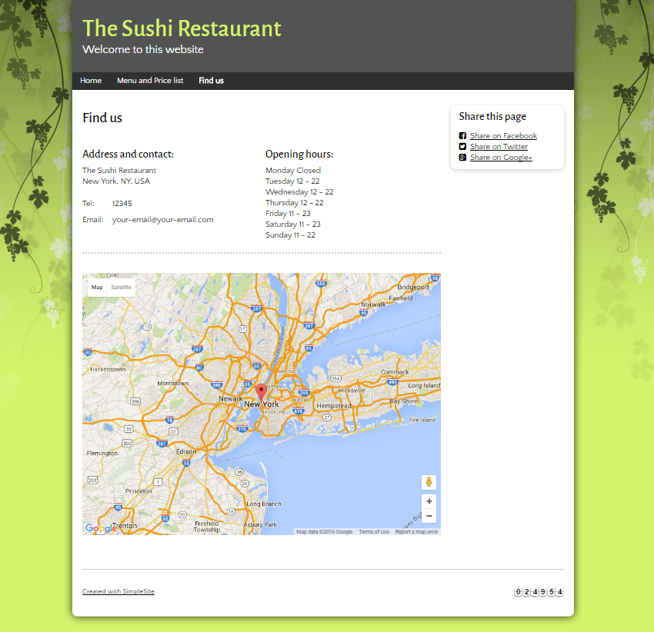

**Guidelines**

* Step 1 : Create web layout
* Step 2 : Create prototype
* Step 3 : Design database base on created prototype
* Step 4 : Code & Test